Getting Started with the Patient Portal

- Request Patient Portal access from any staff member at Family Health Center.
- Review, sign, and agree to the policies and authorization form you will be provided.
- Provide your e-mail address and your preferred pharmacy.
- After this is complete, you can expect to see a welcome e-mail. On this e-mail, you will click on the URL (website) link and use the assigned login and password.
- Once logged into the portal, you should go to “My Account” on the top right of the page. Here you can change your username and password to something only you will know. This is essential to make sure your information remains secure and private! After the above is complete, you should be able to use the site. Here is a screenshot.

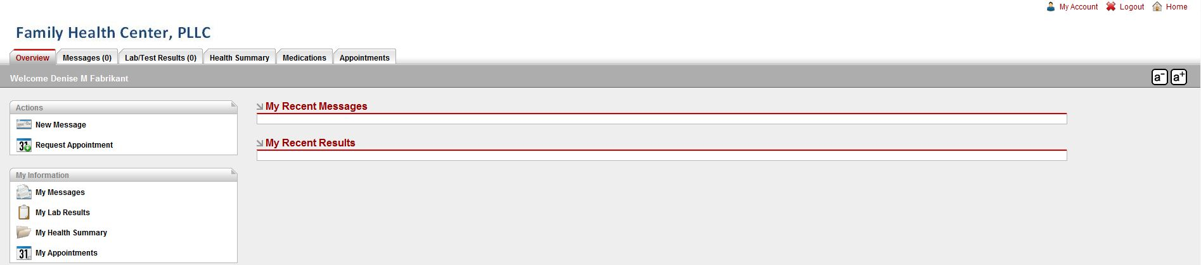

Available components:

- Messages: This allows you to send and receive secure e-mail to/from our staff. This may include attachments, or other information. Use of this is very similar to standard e-mail. Here you can also request a referral, ask billing questions, or even make suggestions on how we can improve the site.
- Lab/Test Results: Here you can receive copies of labs/tests done in the office, test results, and any explanations or comments done by your provider. This is read only area, but if you have questions, you can e-mail us in the messages section.
- Health Summary: Here you can view information entered into various parts of the electronic health record. There are available for you to review and check accuracy as well as print for other physicians or to keep for your records. If it isn’t complete, we might have the information, but it is not yet entered in a way you can view it through the portal. Here you can also make suggestions/comments on the information added, but it will not be a permanent part of your chart until approved by our staff.
- Medications: Here you can see current and past medications written by our office or entered by our staff. You can also request refills here, just please make sure we have your preferred pharmacy information.
- Appointments: In this section you can view upcoming appointments or see requested appointments. In addition, you have the ability to request appointments or schedule directly into open slots.

Access the Patient Portal from our clinic’s main website at www.fhcpllc.com

Policy and procedures for using the Patient Portal

- Email Usage
- Do not use the messaging system of the portal for emergencies or urgent communication. Instead, call 911 for medical emergencies.
- Proper subject matter of messages
- Use the subject matters embedded in the system, if possible, like prescription refills, lab results, appointment requests, etc.
- Sensitive subject matter (HIV, mental health, sexual issues) is not permitted as these are best discussed in person with your doctor.
- We do not refill narcotics/stimulants through the patient portal. Call your pharmacy for refills.
- Be concise in your requests to avoid numerous message exchanges just to clarify your intentions.
- Current functionality of the patient portal includes:
- Messaging via secure email
- Refill requests. Make sure we have your preferred pharmacy on file.
- Viewing and printing of standardized continuity of health record.
- Viewing and updating of health information (subject to approval by the clinical staff).
- Referral requests.
- Appointment requests.
- Appointment management: Confirm, cancel, and reschedule.
- Lab results: View and print lab results including messages from your doctor.
- Billing: Submit billing questions to our billing staff.
- Various updating functions: Demographics, insurance, medications, email, etc. (subject to approval).
- ALL patient portal communication will be included in your patient record.
- Our portal is set up to check your messages when they are viewed, so there is no need to reply that you have read them.
- Privacy:
- All messages you send via the portal will be encrypted (see informed consent which is required).
- Email to our staff should only be via the portal. Regular email is not secure and inappropriate to communicate with our staff.
- Your email address is not shared with anyone.
- Email sent to Dr. Ayo will go into their inbox; however, they may be read by other staff members in an effort to support our providers, something similar to how phone messages might be re-routed. For very personal matters you should speak to your provider in person.
- Response time:
- After initial sign-up for the portal and agreeing to the policy and procedures as well as the informed consent, you will get a welcome message to your email address on file. This message contains your login name and password and a link to our portal web page.
- While we monitor our messaging system throughout the day, we normally respond to non-urgent email within 24 hours, or the next business day.

